Q4 – Control Implicit Conversions
Question: Identify every place in the program where C++ converts a value from one type to another without being told.
Program:

#include <iostream>
using namespace std;

int main() {
int a = 7, b = 2;
double c = a / b;
double d = static_cast<double>(a) / b;

cout << c << " " << d << endl;

char ch = 'A' + 2;
cout << ch << " " << ch + 1 << endl;

bool flag = 5;
cout << flag << " ";
cout << boolalpha << flag << endl;

unsigned int u = 1;
int s = -1;
cout << (s < u ? "s < u" : "s >= u") << endl;

return 0;
}

Output:
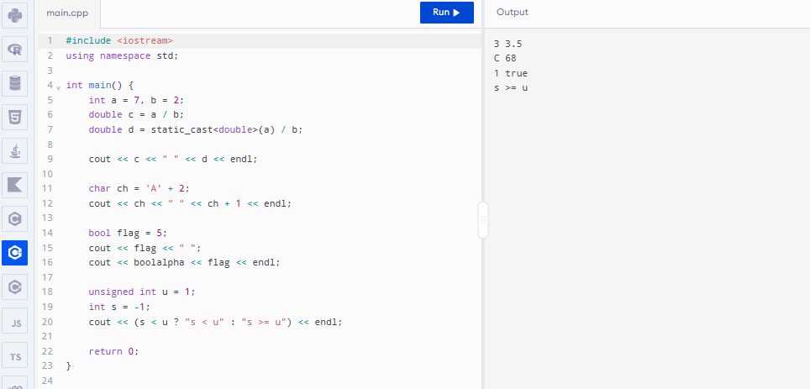

Q5 – Write Correct Expressions with the Right Precedence
Question: Write the expressions for the peak check, the surcharge and the concession.
Program:

#include <iostream>
using namespace std;

int main() {
int x = 5, y = 3;

cout << x + y * 2 << " " << (x + y) * 2 << endl;

int z = x++ + ++y;
cout << z << " " << x << " " << y << endl;

cout << (x > y ? x : y) << " " << x % 4 * 2 << endl;

cout << 10 / 3 << " " << 10 % 3 << " "
<< -10 / 3 << " " << -10 % 3 << endl;

int k = 0;
for (int i = 0; i < 10; i += 3)
k += i;

cout << k << endl;

return 0;
}

Output:
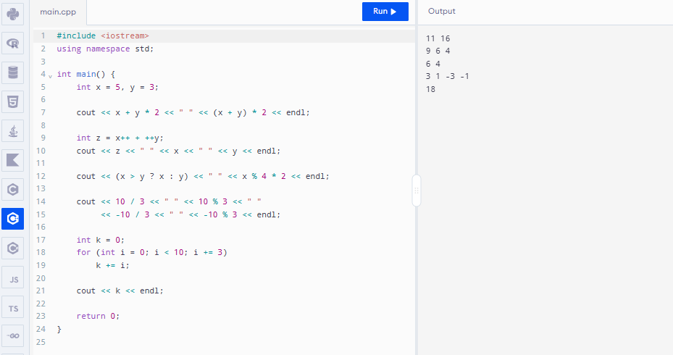

Q6 – Design the Control Structures
Question: Design the decision and looping logic for computing a fare and processing a day's journeys.
Program:

#include <iostream>
#include <iomanip>
using namespace std;

enum class Zone { Inner, Middle, Outer };

constexpr int BASE_PAISE[] = {1000, 2000, 3000};
constexpr int PEAK_SURCHARGE_PERCENT = 20;
constexpr long long MIN_BALANCE_PAISE = 5000;

long long fare(Zone z, bool peak) {
int f = 0;

switch (z) {
case Zone::Inner: f = BASE_PAISE[0]; break;
case Zone::Middle: f = BASE_PAISE[1]; break;
case Zone::Outer: f = BASE_PAISE[2]; break;
}

if (peak)
f += f * PEAK_SURCHARGE_PERCENT / 100;

return f;
}

bool canTravel(long long balance, long long f) {
return balance - f >= MIN_BALANCE_PAISE;
}

int main() {
long long balance = 10000;

struct Trip { Zone zone; bool peak; };
Trip trips[] = {
{Zone::Inner, false},
{Zone::Outer, true},
{Zone::Middle, false}
};

for (const Trip& t : trips) {
long long f = fare(t.zone, t.peak);

if (canTravel(balance, f)) {
balance -= f;
cout << "Fare Rs " << f / 100 << "."
<< setw(2) << setfill('0') << f % 100
<< setfill(' ');
} else {
cout << "Denied (low balance)";
}

cout << " balance Rs " << balance / 100 << endl;
}

return 0;
}

Output:
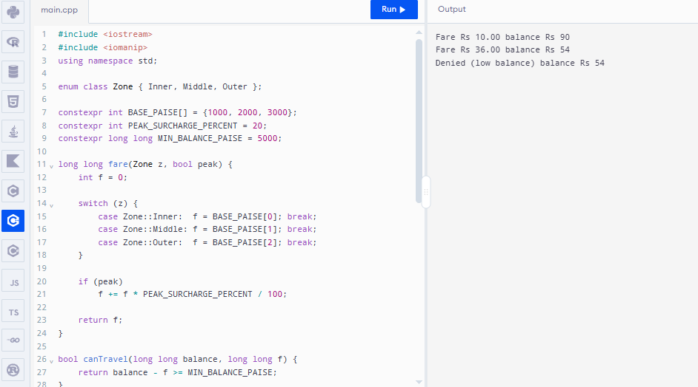

Q10 – Compare Expectations with Execution
Question: Compare what you expected with what actually happened.
Program:

#include <iostream>
using namespace std;

int main() {
int journeys[] = {20000, 500000, 3000000};

for (int n : journeys) {
long long totalPaise = 1LL * n * 3000;
double totalRupees = n * 30.0;

cout << "Journeys: " << n << endl;
cout << "Integer paise: " << totalPaise << endl;
cout << "Double rupees: " << totalRupees << endl;
cout << "Int limit exceeded: "
<< (totalPaise > 2147483647LL ? "Yes" : "No")
<< endl << endl;
}

return 0;
}

Output:
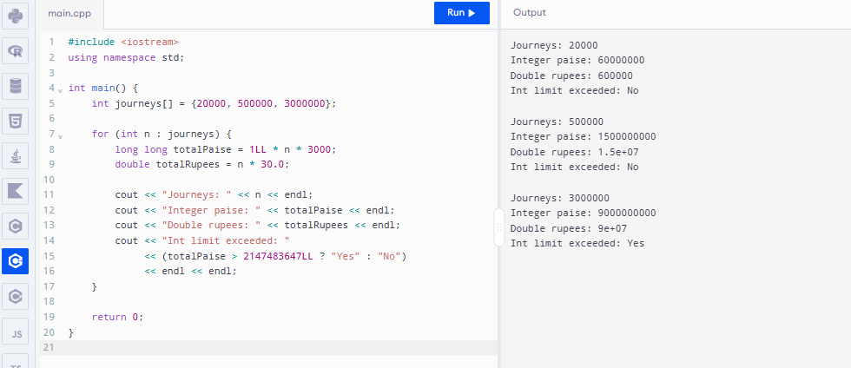

Q11 – Recommend and Defend the Final Design
Question: Recommend the final design for the metro.
Program:

#include <iostream>
using namespace std;

constexpr long long MIN_BALANCE = 5000;

class SmartCard {
long long balance;

public:
SmartCard(long long b) : balance(b) {}

bool canTravel(long long fare) {
return fare >= 0 && balance - fare >= MIN_BALANCE;
}

void deduct(long long fare) {
if (canTravel(fare)) {
balance -= fare;
cout << "Journey accepted" << endl;
} else {
cout << "Journey denied" << endl;
}
}

void showBalance() {
cout << "Balance Rs " << balance / 100
<< "." << (balance % 100 < 10 ? "0" : "")
<< balance % 100 << endl;
}
};

int main() {
SmartCard card(10000);

card.deduct(3000);
card.showBalance();

card.deduct(6000);
card.showBalance();

return 0;
}

Output:
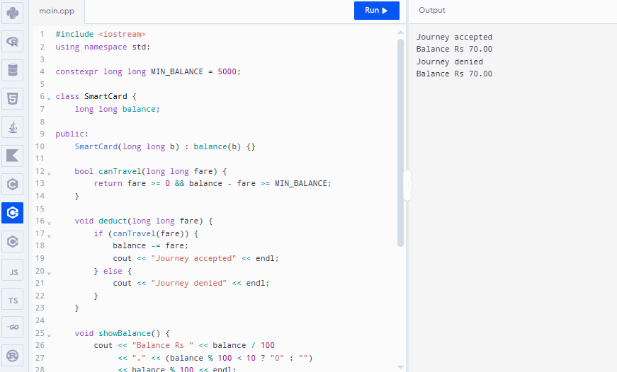

Q12 – Re-evaluate and Adapt the Design
Question: The metro adds a fourth zone (Airport, ₹60), a 10% weekend discount that does not combine with the peak surcharge, and a monthly pass that allows unlimited journeys in two chosen zones.
Program:

#include <iostream>
using namespace std;

enum class Zone { Inner, Middle, Outer, Airport };

constexpr int FARE[] = {1000, 2000, 3000, 6000};

class Pass {
public:
Zone z1, z2;

Pass(Zone a, Zone b) : z1(a), z2(b) {}

bool valid(Zone z) {
return z == z1 || z == z2;
}
};

long long calculateFare(Zone z, bool peak, bool weekend) {
long long f = FARE[static_cast<int>(z)];

if (weekend)
f = f * 90 / 100;
else if (peak)
f = f * 120 / 100;

return f;
}

int main() {
Pass pass(Zone::Middle, Zone::Airport);

cout << "Airport peak fare: Rs "
<< calculateFare(Zone::Airport, true, false) / 100.0
<< endl;

cout << "Outer weekend fare: Rs "
<< calculateFare(Zone::Outer, true, true) / 100.0
<< endl;

cout << "Monthly pass for Airport: "
<< (pass.valid(Zone::Airport) ? "Valid" : "Invalid")
<< endl;

cout << "Monthly pass for Outer: "
<< (pass.valid(Zone::Outer) ? "Valid" : "Invalid")
<< endl;

return 0;
}

Output:
